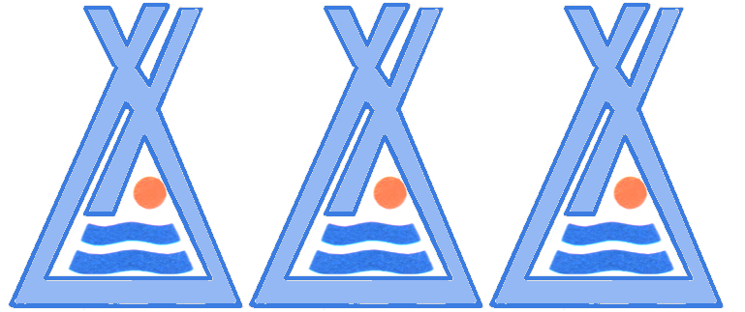
THE CONFEDERATED TRIBES OF THE WARM SPRINGS RESERVATION OF OREGON

Branch of Natural Resources
Fisheries Department
P.0. Box C, Warm Springs, Oregon 97761
Phone (541) 553-3557
Fax (541) 553-7827

June 6, 2017

Operations Manager
U.S. Army Corps of Engineers
Bonneville Lock and Dam
P.O. Box 150
Cascade Locks, OR 97014

Dear Operations Manager:

The Confederated Tribes of Warm Springs Reservation of Oregon (CTWSRO) is requesting access to Bonneville Dam to PIT tag Pacific lamprey during summer 2017. The CTWSRO has been conducting Pacific lamprey research in Hood River and Fifteenmile Creek since 2010. These studies rely on half-duplex PIT tag technology to estimate lamprey escapement past Cushing Falls on Fifteenmile Creek and to document migration patterns in Hood River, where lamprey recently re-colonized after removal of Powerdale Dam in fall 2010. The CTWSRO captures and implants adult lamprey with PIT tags in Fifteenmile Creek for mark-recapture estimates. Because a high proportion of tagged lamprey fall back and fail to return to the study sites, over-winter, then may return to the study site the following year producing an escapement estimate is challenging. Since 2011, when the University of Idaho (UI) began been PIT tagging lamprey and releasing them near Bonneville Dam, the CTWSRO has benefited from additional PIT tagged lamprey entering our study streams. In 2015, the UI lost funding to continue their studies at Bonneville Dam, so the CTWSRO continued tagging lamprey to supplement the number of tagged lamprey to further our research goals. We are asking for permission to continue work in 2017.

We expect to perform this work at Bonneville Dam from May through September and have at least one person on site working with the CRITFC crew. We will be coordinating efforts with Mr. Brian McIlraith, Lamprey Project Leader, CRITFC. The CTWSRO staff will coordinate with Ms. Ida Royer at Bonneville Dam and all other USACE staff to ensure safe operation. We have reviewed the 2017 Guide For Fish Researchers and will comply with all requirements. Permanent CTWSRO staff has current First Aid/CPR training and cards. If temporary CTWSRO staff does not have current First Aid/CPR training, I will see that they obtain this prior to beginning work. Project work plans have been submitted to the Portland District Biologist as well as the Project Fisheries Research Coordinator.

Sincerely,

Andy Johnsen
Confederated Tribes of Warm Springs Reservation of Oregon
Branch of Natural Resources
Lamprey Biologist
P.O. Box C
Warm Springs, OR 97761
(541) 553-3568
andy.johnsen@ctwsbnr.org

cc: Ms. Erin Kovalchuk
Ms. Ida Royer

